EVENT-BASED MEDICAL ORGANIZATION OF THE HANDBALL COMPETITIONS

Medical Commission
CAHB

PLAN

INTRODUCTION
- PREREQUISITES
- COMPOSITION AND ROLE OF THE TEAMS
II.1. Teams
II.2. Role of the Doctors
- ORGANIZATION
- OTHER ASPECTS
IV.1. Ethical Rules
IV.2. Insurance coverage
IV.3. Communication and relations with the media
CONCLUSION

INTRODUCTION

The medical responsibility of a sport event is a unique and difficult adventure that represents an important part of the activity of a sport physician. The medical coverage of a sport event or team is the essence of the field activity of sports medicine. Generally, you are outside of all medical structures, with limited equipment, full and complete responsibility (whatever happens, you are the doctor), significant pressure from the athletes, their entourage, the organizers, the physical environment (rain, cold, snow, dust, noise, etc.). You must act quickly and well whatever the conditions. The world around you is a heightened world of intense competition where every detail, every second counts, where commitment is total and without mercy, and this world expects the same commitment and the same degree of performance from the medical team.
Why are we talking about this subject?
* Because of the lack of knowledge of the federal specifications
* Because of the importance of handball events
* To give means to the coordinating physician to better appreciate his requests and evaluate them
Handball is a contact sport played indoors, which requires an important dynamic with a growing number of participants and spectators. It is considered as a high risk sport.

Table 1 : Risk according to the sport
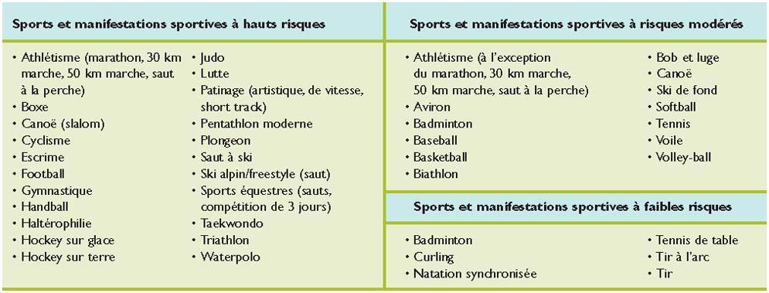

- PREREQUISITE
The federal specifications concern equipment, organization, media, marketing and communication, security, medical and finance.
It is important that the physician is satisfied that he/she has the following conditions :
- He has the capacity to do so (availability, training, interest, athletic level, etc.).
- He has got a valid right to practice.
- He has got the required diplomas. Any national or international event and any national or international team must be supervised by doctors with a certificate of competence in sports medicine
- He/She has a civil liability insurance covering him/her for this specific activity of sports medicine (especially if he/she has to treat professional athletes).
- He has the agreement of his employer (if the physician is an employee) to carry out the activities provided for in the concerned medical supervision
- He is able to assemble a medical team of sufficient size, skills and experience appropriate to the task required.
- He/She is familiar with handball, the physical demands placed on athletes, the risks of injury involved, and the rules of the competition he/she is supervising.

- COMPOSITION AND ROLE OF THE TEAMS
II.1. TEAMS
The list (not exhaustive) of staff is as below:
- The Coordinating Physician
- The match Physician
- First aid teams (at least 2):
- A fixed team near the field in visual contact with the coordinating doctor
- One or more mobile teams, for the spectators (Tribune) and around the venue.
II.2. ROLE OF THE DOCTORS
THE COORDINATING PHYSICIAN must:
- Evaluate the capacity of the hall, equipment (treatment rooms, intervention circuit)
- Evaluate the needs in materials
- Help the staffs of the 2 teams
- Position next to the field in direct relation with the match’s delegate
- Evacuate the injured to the care facilities
- Be in permanent visual contact with the fixed team of first aiders
THE MATCH PHYSICIAN :
- Gives assistance to the staff of both teams (doctor and physiotherapetist of the teams)
- Coordinates the aid in case of serious injury (care, evacuation, hospitalization).
- Give assistance to the doctor dedicated to the spectators
Write a report of activity on the conditions of exercise, the number of interventions, the sending of the report of activity to the organizer and the sending of the medical report to the national federal doctor).
- ORGANIZATION
How do you organize the supervision of a sports event? As in most organizations, it's all about preparation. The better prepared you are, the more capable you will be of handling the imponderables of the sport world. First of all, you need to know the sport concerned, its rules and its specificities. Then, to know the intrinsic risks by reading epidemiological studies of injuries. It is also important to know the handball environment in order to learn the anecdotes useful to determine the worst case scenario. In this initial phase of the preparation, it is necessary to quickly contact the organizing committee in order to determine the needs, expectations and framework of the medical service. According to these different parameters, it is then essential to define the team that will surround you. This team must have great medical and technical skills, but above all it must have a good experience of Handball. It is also necessary to know if the participating teams travel with a team doctor (in this case, the latter will play the role of the treating doctor and must be considered as such in all the confraternal exchanges).
In the general organization, it is necessary that the physician in charge or the person in charge of the logistics of the medical team participates in the organization plan so that the location of the medical units is adapted to the mission (including the circulation of ambulances). At this stage, the person in charge of the medical service must check that his team is identified by name by the organization and that the latter has taken out accident insurance covering the whole team throughout the event. It is also important to inform the local hospitals by letter and to notify them of possible transfers of injured persons to their institution. If it is a large event with a large audience, it is essential to coordinate the medical service with the city's medical brigade.
The next step is to prepare the necessary equipment. First of all, those who plan to regularly engage in this activity should prepare a case or bag containing basic emergency medication, standard analgesics and anti-inflammatories, a stethoscope, a sphygmomanometer (pressure cuff), the list of products authorized by the World Anti-Doping Agency and some means of restraint.

Table 2: Non-exhaustive list of equipment and medications in a sports-oriented medical bag

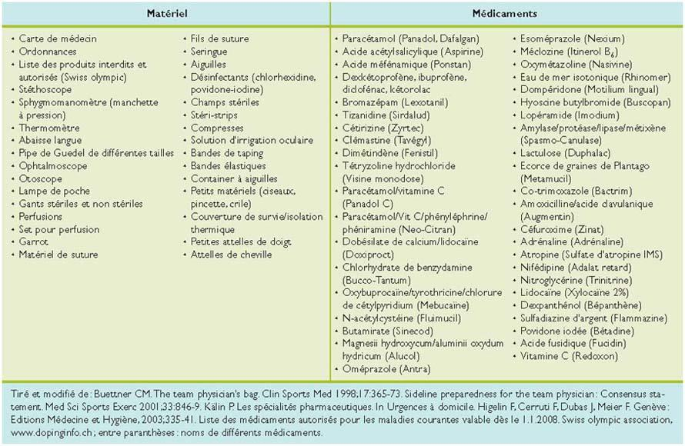
Finally, before the event, it will be essential to gather your team, to explain the functioning of the medical service, to repeat the rules of taking care of an injured person in the particular context of competitive sports, to remind everyone of their responsibilities, especially with regard to medical secrecy, to repeat the basic gestures, the rules of transfer, the specificities of handball and to check the functionality of the equipment.
Avoid a last minute organization, do not arrive at the event tired and stressed, and plan a period of recovery after the event, because you can finish very tired, even exhausted.

- OTHER ASPECTS
IV.1. Ethical rules
Sports medicine is first and foremost medicine and the sports physician, regardless of his or her involvement, carries out his or her activity according to the code of ethics. The physician recognizes the IOC Charter of Sports Ethics. His main mission is to monitor and protect the health of athletes. He will remember that the principle of primum nihil nocere must be applied to all decisions, from a medical, legal and ethical perspective. The physician of a sports event is the treating physician of the athletes during the competition and remains so until the injured or sick athletes are transferred to their homes (especially for foreign athletes). The only exception is when he supervises a sports event where the teams travel with their doctor. In this case, the team physician is considered the athlete's treating physician.
Continuation of sport activity
Sometimes, due to personal motivation or pressure, athletes are led to continue an athletic activity despite the risks and the negative opinion of the practitioner. The physician, exclusively mandated by the athlete, is obliged to dissuade him or her with all due clarity from pursuing a sport activity that is incompatible with the preservation of his or her health. Insofar as the explanations are understood by the athlete (decision-making ability), he/she is free to make his/her own decisions (freedom of decision), with the exception of situations where the athlete is incapable of making rational decisions (e.g. disturbed consciousness, epilepsy, reactive psychosis), with the exception of adolescents under the age of sixteen (parents or legal representative are then involved in the decision) or in the case of a threat to third parties (opposing players or players on the same team, the general public, competitors, etc.) In the latter case, the physician must inform the athlete and encourage him/her to withdraw from participation. If necessary, the physician informs the persons (technical staff, organizers, federations), even against the athlete's will, of his or her inability to participate in training and competition.
Children and adolescents
The general rule is that for children and adolescents between the ages of twelve and sixteen, medical decisions regarding sports are made in consultation with the parents or a legal representative.

Medical confidentiality
The physician is bound by medical secrecy with respect to third parties, the public and the media. Only in the case of imminent danger to the health of third parties can the physician be released from medical confidentiality against the athlete's will. In the case of an athlete whose state of health is of public interest, the physician decides, in agreement with the athlete, what information may be disclosed. If circumstances permit, a written statement will be prepared jointly or read and approved by the athlete to avoid any misunderstanding.
Doping
Doping is contrary to the fundamental principles of sports and medical ethics and can be harmful to the health of athletes. Therefore, the creation, introduction, procurement, distribution, prescription, delivery and monitoring of doping agents are unethical and inadmissible. The physician is familiar with the current anti-doping regulations (WADA and IHF Code) applicable to handball and is aware of the current list of prohibited substances and methods. He also knows the conditions and procedure for granting Therapeutic Use Exemptions (TUE).
IV.2. Insurance coverage
The physician's activity must be covered by insurance. Generally, the organization does not provide liability insurance coverage for the physician.
The independent physician must take out liability insurance. On the basis of the policy, he must determine to what extent his activity as a doctor for a sports event, a team or a federation is insured outside his practice and abroad. It is often necessary to take out additional insurance.
Doctors employed by a hospital, clinic or practice are insured under their employer's liability insurance. In this case, it should be checked on the basis of the policy whether and to what extent the physician's activities for a sports event, team or federation are insured outside the hospital, clinic or practice, or even abroad. In any case, a personal supplementary insurance specific to the practice of sports medicine should be concluded.

IV.3. Communication and relations with the media
The physician has the right to inform the organization of decisions made concerning the athlete in his or her care, including the athlete's fitness to compete. The organization must ensure, through agreements with the athletes, that the latter recognize this right of communication. Through the intermediary of the communication officer or the president of the organization, the physician regularly informs the organization of the execution of his mandate. The physician informs the team or club physicians of events that concern the athletes of this team or club.
The physician is subject to medical secrecy. He may only disclose information about the medical treatment or health status of the athletes to third parties, including the media, with their express consent and that of the person assigned to him. It is important to make every effort to prepare a written press release in conjunction with the athlete concerned or his/her legal representative. This recommendation also applies if the physician is invited to a press conference.
CONCLUSION
The Handball activity has reached a very important milestone.
- Before it was a school and university sport with few participants.
- Today it is a mass sport, with media coverage, international results and an increase in the number of participants and spectators.
- Therefore, the medical coverage of handball competitions must be in adequacy with the importance of the event with respect to the federal specifications.
- The medical supervision of a sports event or a team is an exciting and difficult activity, specific on certain points and which requires an excellent preparation.
Bibliography
- « Couverture Médicale événementielle des compétitions FFHB », Dr Fethy BENSAAD, FFHB Medical commission
- « Supervision médicale d’une manifestation sportive ou d’une équipe de sport », Jacques Menetrey
- « Medical support for hosting events and games », In IOC (International olympic committee) Sport Medicine Manual 2000;451-68.

